AI FireGuard 360

We must connect all sensors with ESP 32 microcontroller.

MATERIAL REQUIRED
Microcontroller
- ESP32 WROOM 32E
Sensors
- MQ2, MQ135, FLAME, PIR, DHT11

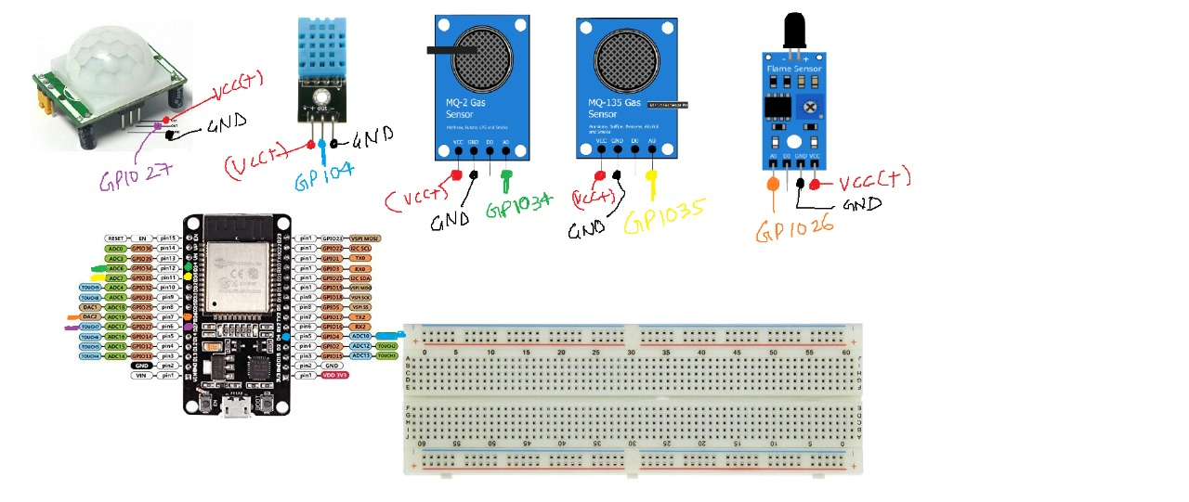

ARDUINO IDE
Step 1: Install the ESP32 Board
Link: https://docs.sunfounder.com/projects/esp32-starter-kit/en/latest/arduino/arduino_start/install_esp32.html

Step 2: Manually Install Driver for ESP32
Link: https://docs.sunfounder.com/projects/esp32-starter-kit/en/latest/faq/install_driver.html#install-driver

FIREBASE DATABASE

Step 1: Create Firebase Project
- Go to Firebase Console
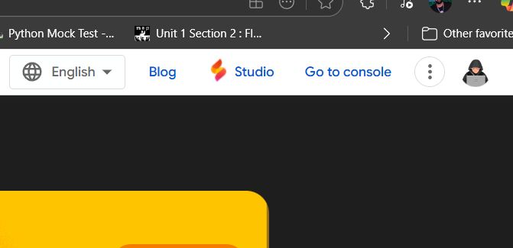
- Click “Add Project” → Give it a name (e.g., FireGuard360).
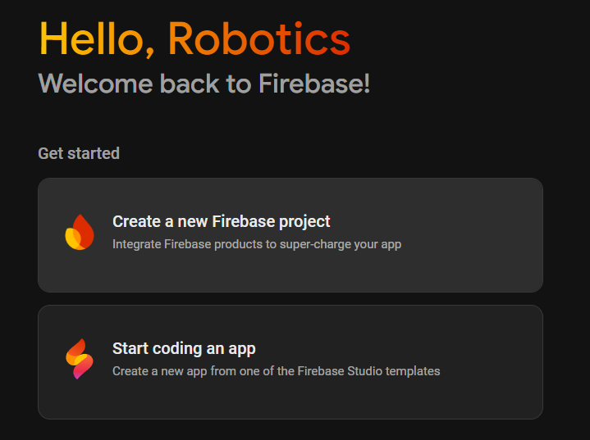
- Disable Google Analytics (optional) → Click Create Project.

Step 2: Add Realtime Database
- In your project, from the left menu, click Build → Realtime Database.
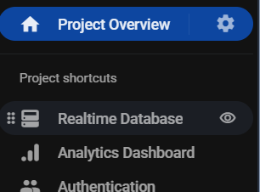
- Click Create Database.
- Choose the region closest to your location (e.g., asia-south1 for India / UAE).
- Select Start in test mode (for now, later you can add rules).
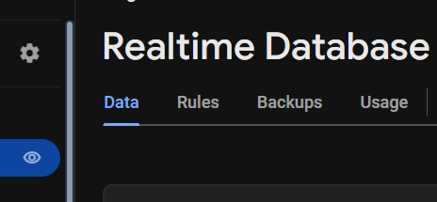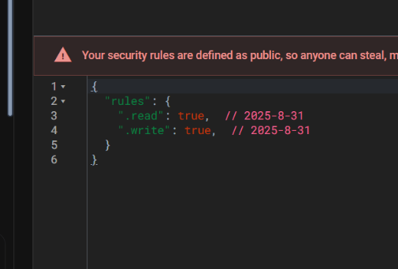

- Done! You’ll now get a Database URL like:
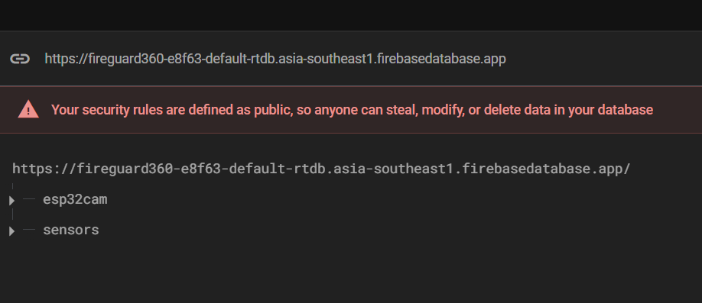

- Make your sign-in method Anonymous:
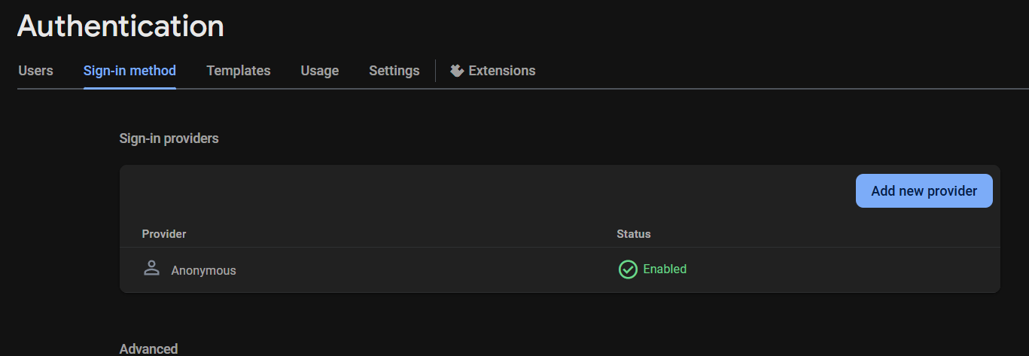

Step 3: Get API Key
- Go to Project Settings → General Tab.
- Scroll down to Your Apps → Click Web App (</>) → Register App.
- Copy the Web API Key from the config snippet, it will look like:
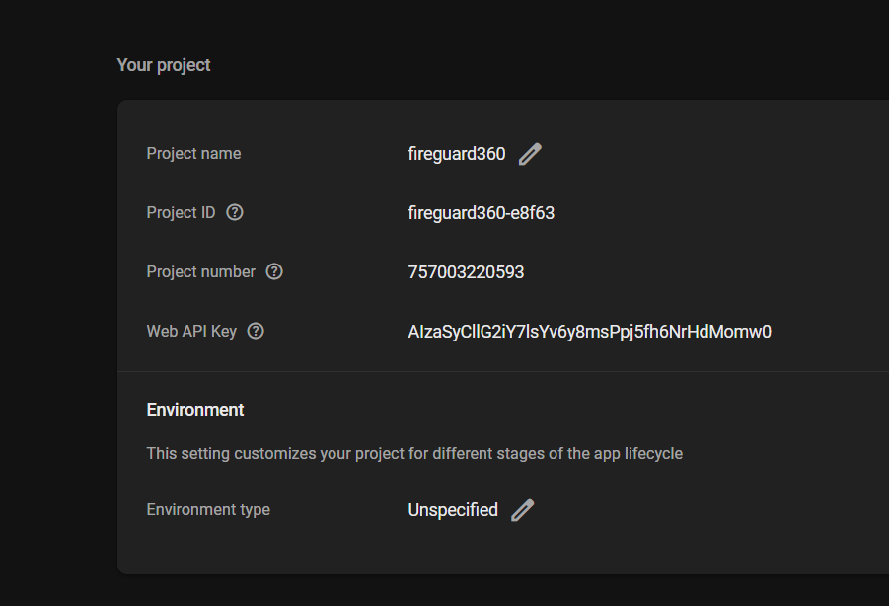

Step 4: Add Your Firebase Credentials in Arduino Code

